Snake Body - drawings.

Segment length is 90 mm including Universal Joints. Est total snake length is 1060 mm being 10 x segments (900mm) plus head (60mm) and tail (100mm) pieces.

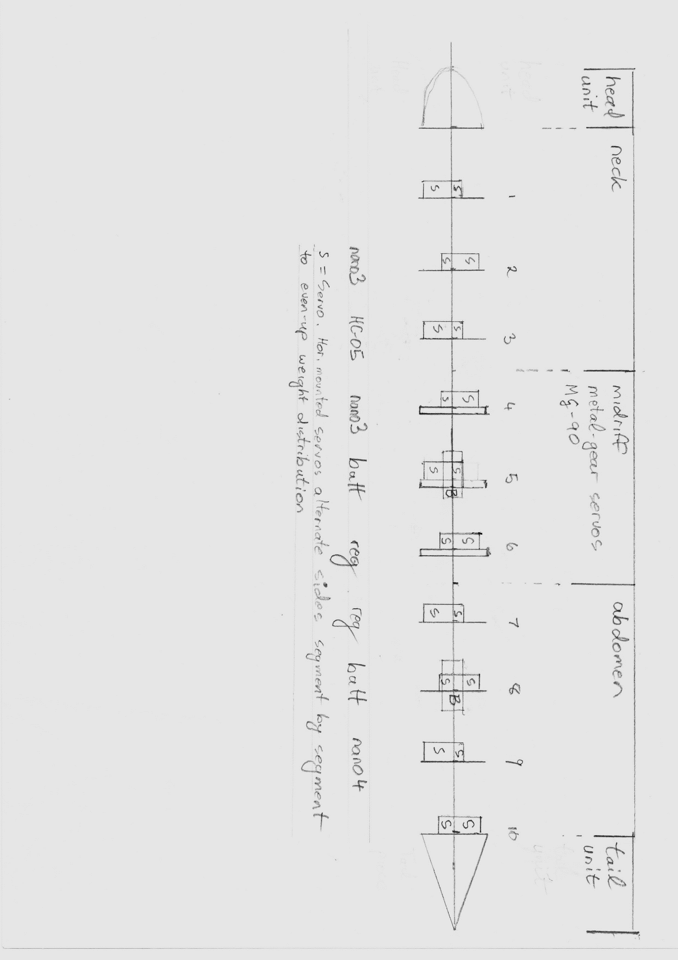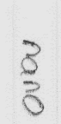

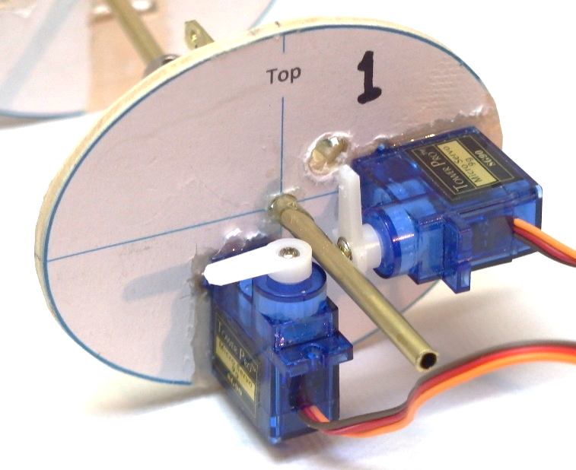S = Servo. Horizontally-mounted servos alternate sides segment by segment.  
 to even-up weight distribution.

B=Battery Wild Scorpion 2S - 7.4V nominal - 500mAH - mounted into segments 5 and 8.  
Segments 5 and 8 have vertically mounted servos in the top half of the "rib"  
leaving bottom half clear to mount the battery.  
Power supply to segments 1-5 is separate to and independent of   
power supply to segments 6-10



Snake Body - power supply.

Segment length is 90 mm including Universal Joint. Est total snake length is 1060 mm being 10 x segments (900mm) plus head (60mm) and tail (100mm) pieces.

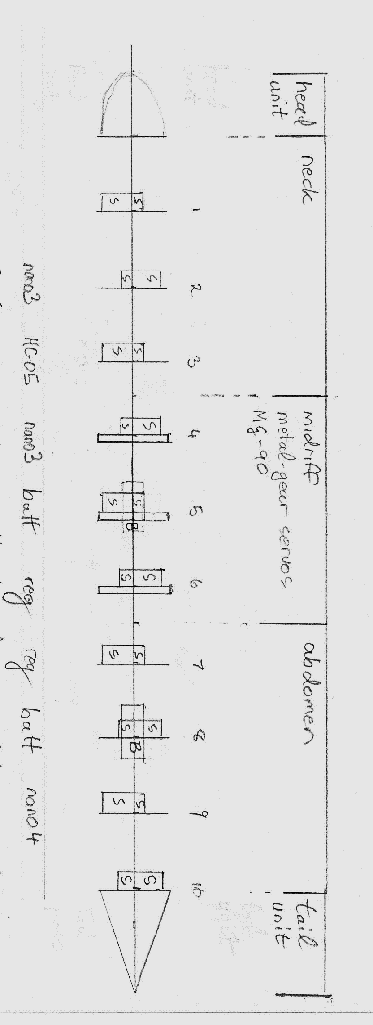

Batt

Batt

Reg01 and Reg02 are regulators providing 5.4 V output from 2S Lithium Ion Battery supply nominally 7.4V

Reg01 is mounted on Rib06 but it feeds power to Rib01 - Rib05.

Reg02 feeds Rib06 - Rib10

If we later feed power to the head computer then for load-sharing,   
line from Reg02 will extend to the head. Shown here as a dotted line.

Snake Body - Arduino Nano microcontrollers.

Segment length is 90 mm including Universal Joints. Est total snake length is 1060 mm being 10 x segments (900mm) plus head (60mm) and tail (100mm) pieces.



**I2C**

**Bluetooth-Serial**

Microcontroller Arduino Nano "Spinal Cord" notes:

Arduino Nanos are shown as blue rectangles, Bluetooth module HC-05 as brown.   
Brown lines represent Bluetooth-Serial-Nano02 wiring.   
Purple lines represent I2C bus. Nano02 is the I2C master unit. Orange lines represent Nanos-Servos wiring.

Nano01 on Segment02 controls 6 Servos on Segment01, Segment02, Segment02

Nano02 on Segment04 controls 6 Servos on Segment04, Segment05, Segment06.   
Nano2 also acts as the Bluetooth-Serial to I2C router.

Nano03 on Segment09 controls 8 Servos on Segment07, Segment08, Segment09, Segment10

HEAD - under evaluation for the "brain" are:

Android SmartPhone (Vodafone VFD-300) - programming in JavaScript as enabled by the DroidScript app.

Android SmartWatch (XS01) - programming in JavaScript as enabled by the DroidScript app.

Raspberry Pi Zero Linux OS - programming in JavaScript as enabled by the Node.js platform.